Assignment 6: Implement Basic Search Strategies – 8-Queens Problem

Problem Statement

The goal of this assignment is to solve the 8-Queens problem using backtracking, a basic search strategy. The challenge is to place 8 queens on an 8×8 chessboard such that no two queens can attack each other (no two queens share the same row, column, or diagonal).

Objectives
- Understand and apply search strategies for constraint satisfaction problems.
- Solve the 8-Queens problem efficiently using backtracking.

Theory

What is the 8-Queens Problem?

The 8-Queens problem is a classic constraint satisfaction problem (CSP) in which eight queens must be placed on a chessboard such that no two queens threaten each other. Since queens can move horizontally, vertically, and diagonally, careful placement is required to ensure safety.

Methodology
- Start with an Empty Board
Begin with an empty 8×8 chessboard with no queens placed.
- Place Queens One by One
Try placing a queen in each column of the current row. Before placement, check if the position is safe (i.e., not attacked by any previously placed queen).
- Use Backtracking
  - If placing a queen results in a conflict, backtrack by removing the last placed queen and trying the next possible column.
  - Continue recursively until all 8 queens are safely placed.
- Continue Until a Valid Configuration is Found
The algorithm systematically explores all possible arrangements until a solution is achieved.

Working Principle / Algorithm
- Initialize the Board
Create an 8×8 array representing the chessboard, initially empty.
- Recursive Function to Place Queens
  - Function takes the current row as input.
  - If all queens are placed (row = 8), a solution is found.
- Check Columns in Current Row
  - For each column, check if placing a queen is safe (no attacks from other queens).
  - If safe, place the queen and recursively place the next queen in the next row.
- Backtrack if Necessary
  - If no valid placement is possible in the current row, remove the last placed queen and try the next column.
- Output
  - Print the board configuration when a valid solution is found.

Advantages
- Simplicity: Easy to implement and understand.
- Effectiveness: Can explore all possible configurations to find a solution.

Disadvantages / Limitations
- Exponential Growth: The number of possibilities grows exponentially with board size, making large N-Queens problems computationally expensive.
- Performance: Many backtracking steps may be needed, leading to high time complexity for larger boards.

Diagram

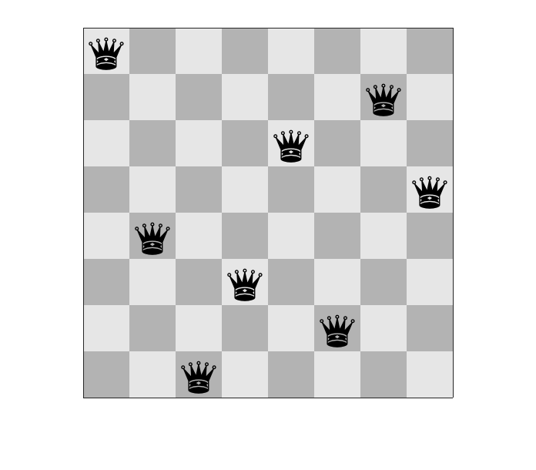

Conclusion
Basic search strategies like backtracking can effectively solve constraint problems such as the 8-queens problem. This approach not only provides a valid solution but also enhances the understanding of how search algorithms work in problem-solving contexts.
Code:-
public class EightQueens {

static final int N = 8;

// Utility function to print the board with '_' for empty cells
static void printBoard(int[] board) {
for (int i = 0; i < N; i++) {
for (int j = 0; j < N; j++) {
if (board[i] == j)
System.out.print("Q ");
else
System.out.print("_ ");
}
System.out.println();
}
System.out.println();
}

// Check if placing a queen at row, col is safe
static boolean isSafe(int[] board, int row, int col) {
for (int i = 0; i < row; i++) {
// Check same column
if (board[i] == col) return false;
// Check diagonals
if (Math.abs(board[i] - col) == Math.abs(i - row)) return false;
}
return true;
}

// Recursive function to solve 8-Queens
static boolean solveNQueens(int[] board, int row) {
if (row == N) {
// All queens placed
printBoard(board);
return true; // change to 'false' if you want all solutions
}

boolean foundSolution = false;
for (int col = 0; col < N; col++) {
if (isSafe(board, row, col)) {
board[row] = col; // Place queen
// Recursively place rest of queens
foundSolution = solveNQueens(board, row + 1) || foundSolution;
// Backtrack (not needed explicitly as we overwrite board[row])
}
}
return foundSolution;
}

public static void main(String[] args) {
int[] board = new int[N]; // board[i] = column of queen in row i
if (!solveNQueens(board, 0)) {
System.out.println("No solution exists");
}
}
}
Output :-
Q _ _ _ _ _ _ _
_ _ _ _ Q _ _ _
_ _ _ _ _ _ _ Q
_ _ _ Q _ _ _ _
_ _ _ _ _ Q _ _
_ Q _ _ _ _ _ _
_ _ _ _ _ _ Q _
_ _ Q _ _ _ _ _

